Problem 2
(a) plot variational objective function | (b) plot $1/E\left[α_{k}\right]$
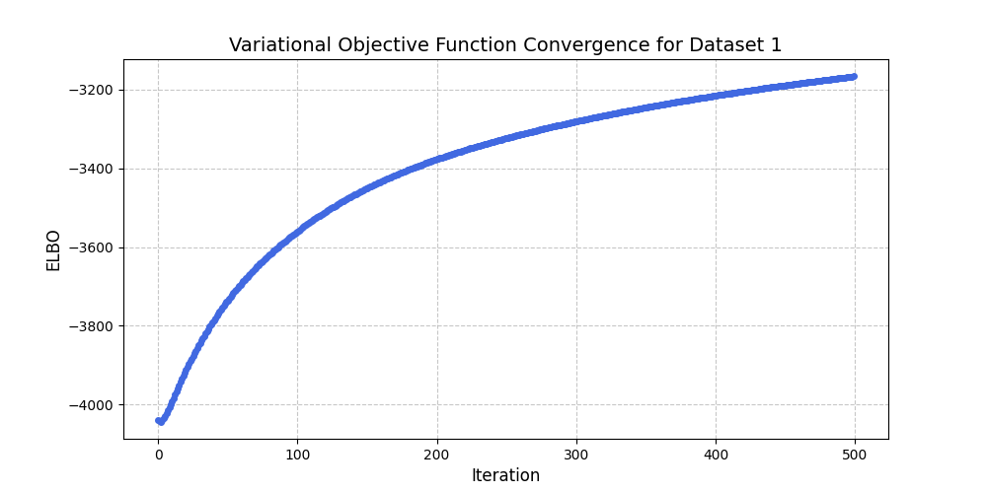 | 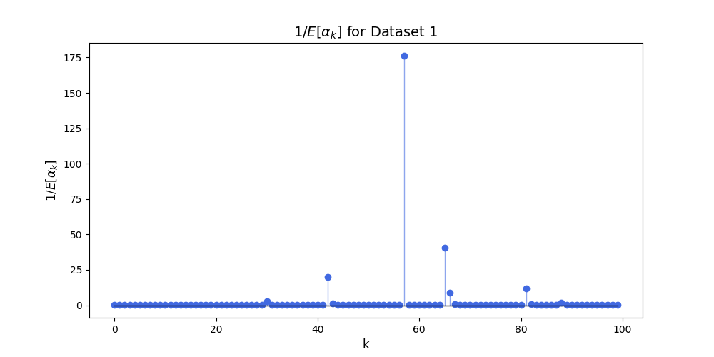
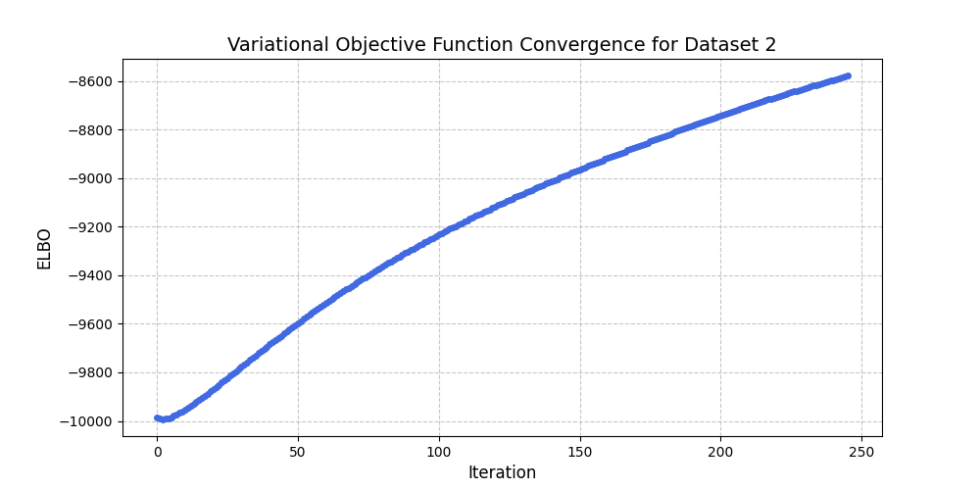 | 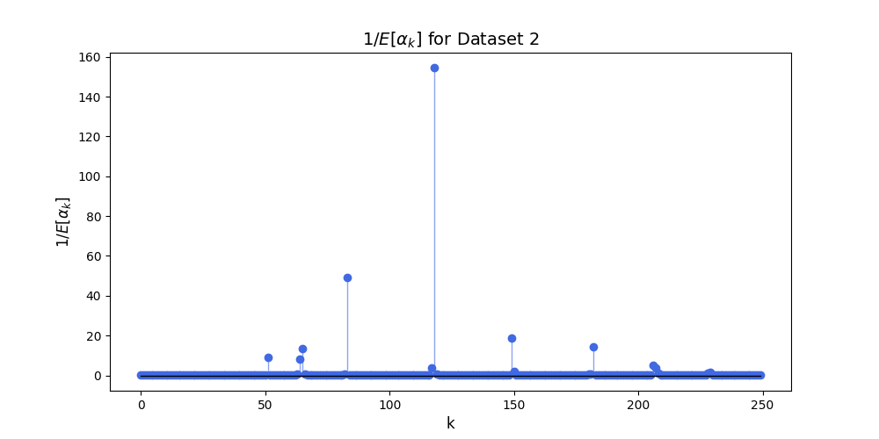
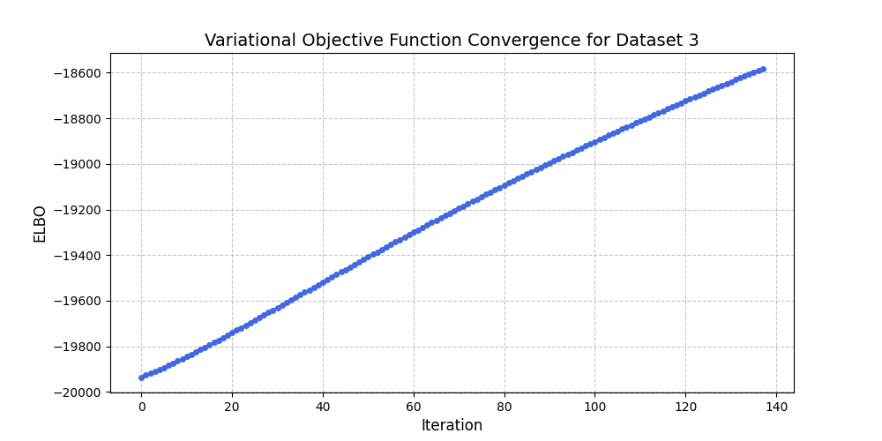 | 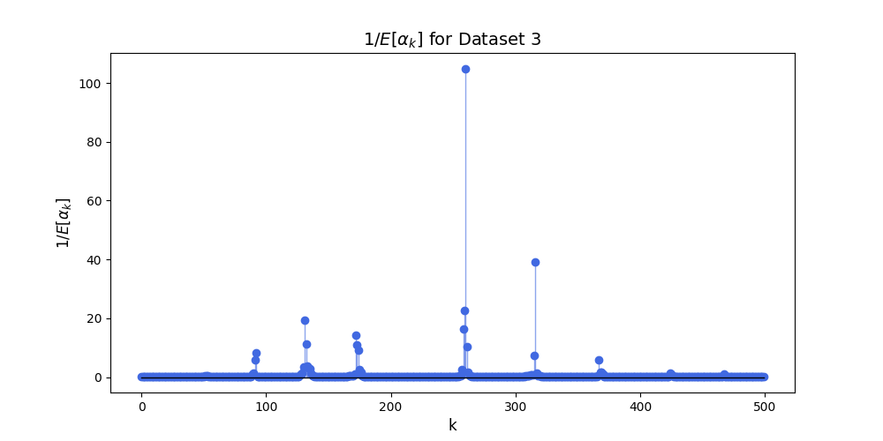
(c) $1/E\left[λ\right]$ at final iteration
Dataset 1: 0.926
Dataset 2: 1.112
Dataset 3: 1.022

Plots for (d) is on the next page

(d)
